**CL-IX (Distributed Computing Systems Lab)**

Assignment 3

**Roll No :** 43159

**Name :** Sakshi Tantak

**Batch :** P-11

**Problem Statement :**

To develop any distributed application using CORBA using JAVA IDL.

**Objectives:**

Students will be able to implement any distributed application based on

CORBA.

**Tools:**

Java 8 with IDLJ Compiler **Theory:**

CORBA:

* Stands for Common Object Request Broker Architecture. ● It is a specification for creating distributed objects and NOT a programming language.
* It promotes design of applications as a set of cooperating objects.
* Clients are isolated from servers by interface.
* CORBA objects run on any platform,can be located anywhere on the network and can be written in any language that has IDL mapping. ● Working:

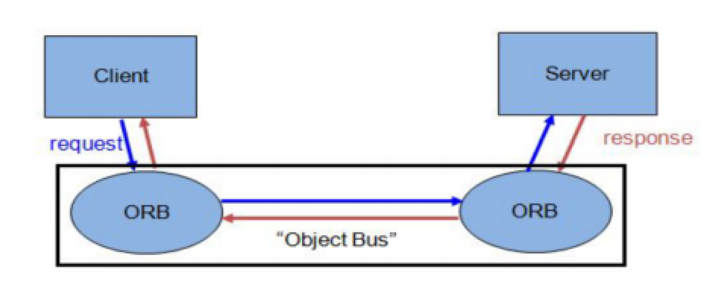

* A CORBA(Common Object Request Broker Architecture) application is developed using IDL (Interface Definition Language).
* IDL is used to define interfaces and the JavaIDL compiler generates skeleton code.
* CORBA technology is an integral part of the Java platform. It consists of an Object Request Broker(ORB), APIs for the RMI programming model, and APIs for the IDL programming model.
* The Java CORBA ORB supports both the RMI and IDL programming models.
* I will be using the IDL Programming Model for this assignment.

CORBAArchitecture :

* Object Request Broker is an Object Manager in CORBA. ● It is present on the clients ide as well as server side (allows agents to act as both clients and servers of remote objects).
* On client side the ORB is responsible for○accepting requests for a remote object
  1. finding implementation of the object

○ Accepting client-side reference to the remote object(converted to a language specific form, e.g., a Java stub object)

○ Routing client method calls through the object reference to the object implementation.

* On server side the ORB○lets object servers register new objects
  1. receives requests from the client ORB

○ uses object’s skeleton interface to invoke object’s activation method

○ creates a reference for a new object and sends it back to the client.

○ Between the ORBs, Internet Inter-ORB Protocol is used for communication.

What is IDL?

* IDL is Interface Definition Language which defines protocol to access objects.
* Stub lives on the client, and pretends to be a remote object. ●

Similarly,Skeleton lives on the server, receives requests from stub,talks to the true remote object and delivers the response to stub.

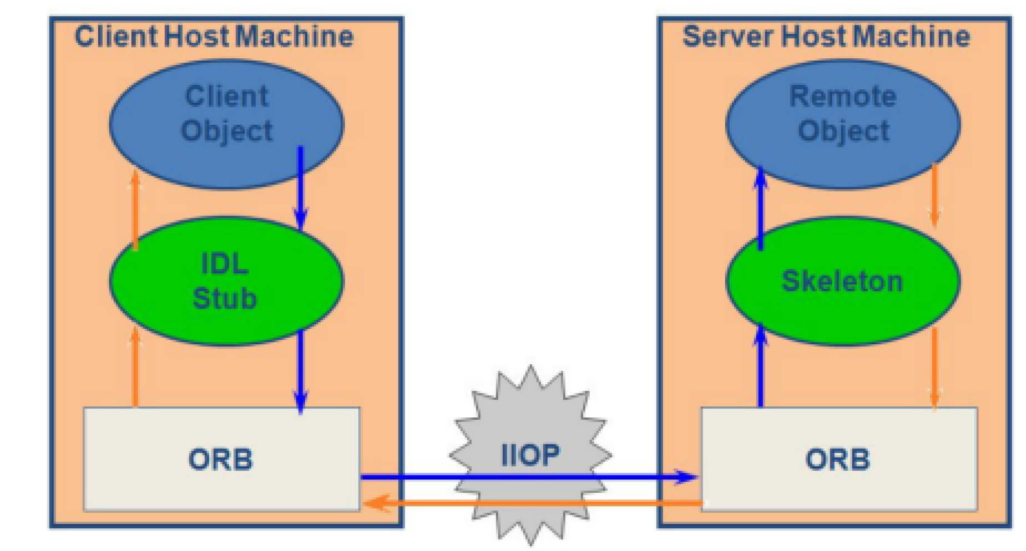

How to use CORBA with JAVA?

* Java-idl is a technology for distributed objects, i.e objects interacting on different platforms across a network.
* Translates IDL concepts to Java Language Constructs.
* It enables objects to interact regardless of whether they're written in the Java programming language or another language such as C, C++. ● This is possible because JavaIDL is based on the Common Object Request Brokerage Architecture (CORBA), an industry-standard distributed object model.
* Each language that supports CORBA has its own IDL mapping, and as its name implies, Java IDL supports the mapping for Java.
* To support interaction between objects in separate programs, JavaIDL provides an Object Request Broker, or ORB.
* The ORB is a class library that enables low-level communication between JavaIDL applications and other CORBA-compliant applications.
* On the client side, the application includes a reference for the remote object. The object reference has a stub method, which is a stand-in for the method being called remotely.
* The stubisactually wired into the ORB, so that calling it invokes the ORB's connection capabilities, which forwards the invocation to the server.

**Conclusion:**

Thus, in this assignment, I learned how to use CORBA in Java using IDL and IDLJ for distributed computing systems.